Guidelines for sending email with Constant Contact
- Select “Newsletter Professional.”
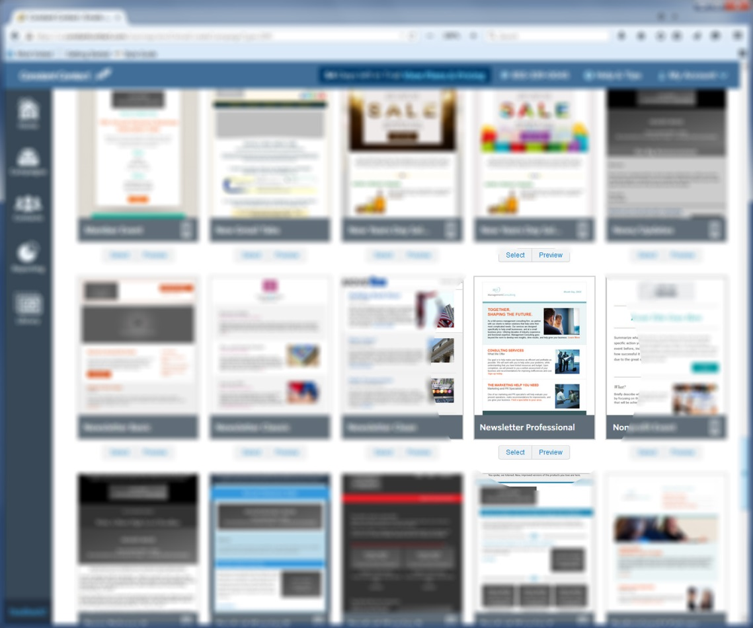
- After selecting “Newsletter Professional,” there are a few changes that need to be made.
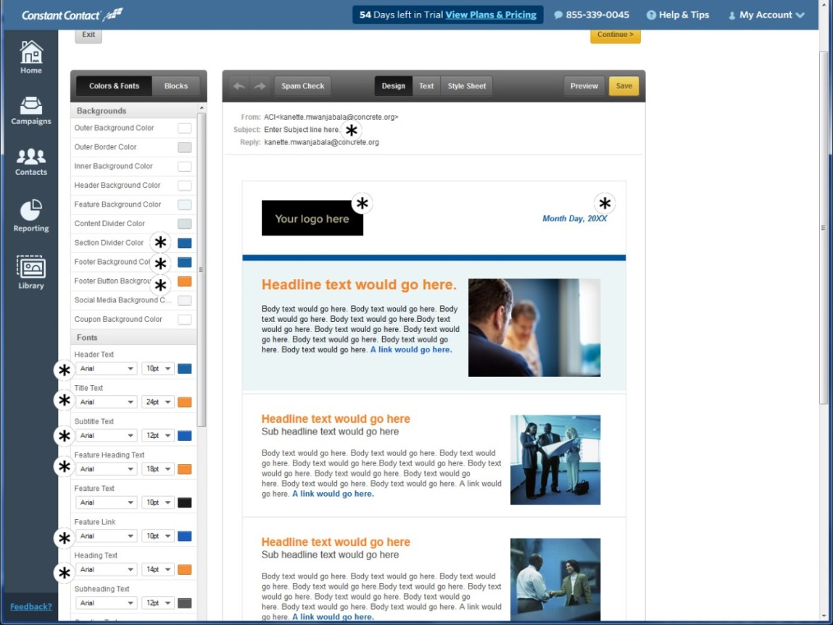
Step 1: Make sure you have a subject line.
Step 2: Change the logo to your own (click on the “your logo here” image, then right click, select “Change,” and either pull from your library or upload a new logo).
Step 3: Change the month, day, and year.
Step 4: Change the section divider, footer background color, header text, subtitle text, feature link, main link, social media link, coupon subheading text, coupon text, and coupon border color to this blue: 0, 83, 155
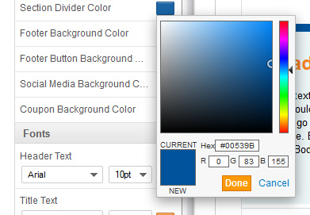
Step 4: Change the title text, feature heading text, heading text, outer text, and coupon heading text color to this orange: 245, 130, 31.
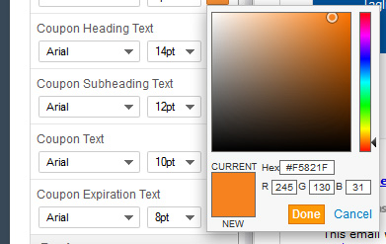

Leave the fonts at Arial and then leave the colors as-is.
You may now insert your personalized content and add photos to the E-Newsletter.
For general news and announcements, you should reduce the article boxes down to one (by clicking delete) and then insert your event/new information and photo.

