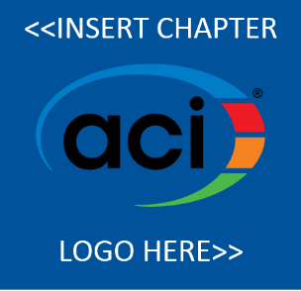
New Global Benefits
Now is the time to join your local ACI Chapter!

Sign up to become a member of the <<insert chapter region>> Chapter of the American Concrete Institute, and you will join the premier community dedicated to the best use of concrete. In addition to the benefits received locally, all local chapter members will also receive select global benefits.

In full, you’ll receive the following when joining the <<insert chapter region>> Chapter of ACI:
- <<insert local chapter benefit #1>>;
- <<insert local chapter benefit #2>>;
- <<insert local chapter benefit #3>>;
- <<insert local chapter benefit #4>>;
- <<insert local chapter benefit #5>>;
- Free digital subscription to Concrete International magazine*;
- Three ACI University on demand courses*;
- Listing in the ACI Member Directory*; and
- A printable ACI membership certificate*.

Sign up by May 1st at:
<<insert chapter website>>
<<insert chapter phone>>
*Select global benefits offered by the American Concrete Institute. These benefits only available if chapter chooses to participate.
Interested in more?
Individual, Organizational, and Sustaining members of ACI receive discounts and additional benefits. Visit www.concrete.org/membership to learn more.

