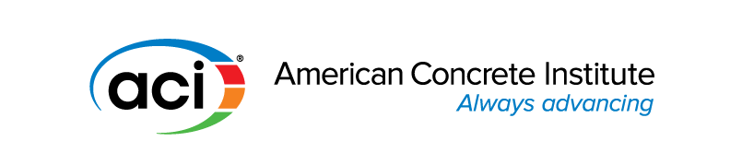

NOMINATION FOR ACI STRATEGIC ADVANCEMENT AWARD

CRITERIA:

- Given for profound support in implementing membership and customer satisfaction
- Given for profound support in implementing the quality of ACI programs, products and services
- Given for profound support in implementing global credibility and impact

All persons, firms, corporations, or organizations affiliated with ACI are eligible to be
considered for this award.

Date

Name of Candidate _________________________________________________________________

ACI Member Yes No

Present Position/Title _________________________________________________________________

Company/Institution _________________________________________________________________ __________________________________________________________________________

Business Address _________________________________________________________________
__________________________________________________________________________
_________________________________________________________________ __________________________________________________________________________

Email _________________________________________________________________

Phone ________________________________________________________________ __________________________________________________________________________

Please provide information to demonstrate the profound support provided in implementing one or more of the objectives of the Strategic Plan. (Strategic Plan shown at end of this form)

ACI activities/Offices held (committees, chapters, technical, advisory, administrative, leadership)

Brief Citation: Please provide a brief statement on why this candidate should be nominated.
(A MAXIMUM OF 5 SENTENCES)

THIS CITATION IS MANDATORY TO COMPLETE THE NOMINATION

SAMPLES OF PAST CITATIONS

“for recognition of the significant contributions he has made in implementing membership and customer satisfaction, in particular through the exchange of information with the Concrete Institute of Australia (CIA), expanding member benefits for both organizations”

“for her innovative and motivational teaching how to implement quality ACI programs, products and services”

“for the association’s commitment to use an innovative approach in implementing global credibility of the concrete industry, in particular through the joint efforts to support global concrete related associations”

Nomination Submitted By:

Phone: Email:

Date Submitted:

Please return completed form to: American Concrete Institute
38800 Country Club Drive ♦ Farmington Hills, MI 48331
Tele: +1-248-848-3700 ♦ Email: ACIAwards@concrete.org

ACI Strategic Plan

Our Future | Vision
ACI envisions a future where everyone has the knowledge needed to use concrete effectively to meet the demands of a changing world.

Our Business | Mission

ACI develops, disseminates, and advances the adoption of its consensus-based knowledge on concrete and its uses.

Our Markets | Who We Serve
  - ACI members
  - ACI chapter members
  - Customers

Our Beliefs | We Operate With
  - Consensus
  - Credibility
  - Camaraderie
  - Benefit to society
  - Personal and professional growth

Our Strategic Goals and Objectives

Engagement
ACI will work to increase participation of and add value for its members, chapter members, and customers.

Outcome
ACI will increase the number of active members and satisfied users of its products and services.

Objectives
  - Increase opportunities for professional growth
  - Strengthen relationships between ACI and its chapter members
  - Engage constituents interested in certification

Outreach
ACI will positively impact the global concrete community through mutually beneficial alliances.

Outcome
ACI will establish and expand strong and productive relationships with external organizations and individuals.

Objectives
  - Actively seek opportunities to advance national and global outreach
  - Establish relationships with regulatory authorities to advance adoption

Leadership
ACI will provide leadership to ensure our customers are equipped to sustainably address the needs of a changing world.

Outcome
ACI will be a recognized leader and partner in advancing concrete as a solution to society's needs.

Objectives
  - Proactively gather and share information on transformational ideas, practices, and techniques
  - Quickly respond to consumer needs and global trends for concrete information

Structure
ACI will improve the organization and processes through which its programs, products, and services are produced and deployed.

Outcome
ACI will be more efficient, agile, and effective, while maintaining 'ACI quality'.

Objectives
  - Structure ACI and dedicate resources to quickly develop or adapt programs, products, and services
  - Enhance member and customer experience through continuous improvement

