Durability of Concrete in Tidal Environment
(70 Characters Maximum, Title case preferred)
by John Smith and David Lee

(NOTE: The title, names, text, equations, tables and figures have been altered and pasted from different manuscripts for the purpose of format illustration ONLY.
This format can be used as a template to copy and paste your manuscript titles and sections.)

Biography: (75 Words Maximum for each author) ACI member John Smith is a Research Engineer at the Materials Division, Port and Airport Research Institute,………. He received his BS from …..; MS from……; and PhD from……. He is a member of ACI Committees 221 (Aggregates), 302 (Construction of concrete floors), and 325 (Concrete pavements). His research interests include durability of reinforced concrete structures in the marine environment.
David Lee is a researcher at………..

ABSTRACT (or SYNOPSIS) (150 Words Maximum)

A detailed investigation on the concrete specimens (3.94 in. [100 mm] diameter and 7.87 in. [200 mm] height) (Units of measurement must be SI primary or dual units if US [in.-lb]) made with different chemical admixtures was carried out after 10 years of tidal exposure. Chemical admixtures include air-entraining admixture (vinsol), water-reducing admixture (lingosulfonate group), various high-range water-reducing and air-entraining admixtures (naphthalene, melamine, polycarboxyl and amino-sulfonate group) and drying-shrinkage-reducing admixture (glycol ether plus amino alcohol derivatives). The specimens were tested for compressive strength, Young’s modulus of elasticity, carbonation depths, chloride ingress, pore size distribution, electrochemical and physical evaluation of steel bar’s corrosion in concrete, examination of steel-concrete interfaces, and mineralogy of the mortar portions of concrete…………..

Keywords: (9 Keywords Maximum; alphabetical order) chemical admixture; chloride ingress; corrosion; durability;…………….

INTRODUCTION
Water-reducing chemical admixtures are used to produce concrete of higher strength, obtain a specified strength at lower water-cementitious ratios (w/c), or increase the slump of a given mixture without an increase in water content. Numerous studies on the properties of fresh concrete mixed with different chemical admixtures were carried out to investigate the fresh concrete properties or the concrete properties at an early age of exposure. There were also several international conferences held focusing on the chemical admixtures in the last couple of decades. Detailed studies on the long-term performance of concrete mixed with different chemical admixtures, however, are very scarce in the technical literature. Therefore, studies on the long-term performance of chemical admixtures will be. …………….

RESEARCH SIGNIFICANCE (100 Words Maximum)
Different types of high-range water-reducing and air-entraining chemical admixtures were developed in the last couple of decades. Most of the studies on these admixtures were carried out to judge the properties of fresh concrete, or the properties of concrete at an early age. Studies on the long-term performance of concrete made with different water-reducing admixtures are very scarce in the technical literatures. The authors believe that this detail study dealing with the long-term performance of different chemical admixtures is carried out for the first time and will be very useful to concrete technology.

Experimental Investigation (or Experimental Procedure)
Cylinder specimens with and without steel reinforcements (3.94 in. [100 mm] diameter and 7.87 in. [200 mm] height) of 19 separate cases were investigated. The variables include cement types (ordinary portland cement, blended cement replaced by slag powder of 4080 and 7900 cm²/g), air-entraining (vinsol) chemical admixture, water-reducing (lignosulfonate type) chemical admixture, high-range water-reducing and air-entraining (naphthalene, melamine, polycarboxyl, and amion-sulfonate types) chemical admixture, drying-shrinkage-reducing chemical admixture (glycol ether plus amino alcohol derivatives), slag content, and w/c. The specimens were exposed to a tidal pool for 10 years using seawater. In each case, four specimens without reinforcement and three specimens with reinforcement were investigated……………

Materials
Ordinary portland cement (OPC) and blended cements by replacing a portion of the cement with slag powder were used. Two kinds of slag powders were used with Blaine fineness of about 7900 cm²/g (Slag 1) and 4080 cm²/g (Slag 2). The physical properties and chemical analysis of the cement and slag powders are listed in Table 1. River sand and crushed granite coarse aggregates were used. The specific gravity, water absorption, and fineness modulus of sand (passing through 0.20 in. [5 mm] sieve opening size) are 2.63, 1.63 and 2.73, respectively….
The characteristics of CFRP tendons/CFCC strands are summarized in Table 2…………..

Specimens
Plain and reinforced cylinder specimens of diameter 3.94 in. (100 mm) and length 7.87 in. (200 mm) were investigated. The test setup is shown in Fig. 1. Round steel bars of diameter 0.35 in. (9 mm) and length 5.51 in. (140 mm) were embedded at cover depths of 0.79 and 1.79 in. (20 and 45.5 mm).

Items of investigation
At the age of 28 days, plain concrete specimens were tested for compressive strength and Young’s modulus of elasticity of concrete as per JIS A1108 and JSCE G502, respectively. Also, after 10 years of continuous exposure, the specimens were transferred from the exposure site to the laboratory, cleaned, and then tested for compressive strength and Young’s modulus of elasticity……………..

Analytical investigation (or analytical procedure)
The maximum prestress force in the CFRP tendons should be limited to 65% of the specified tensile strength of tendons^{4, 5} (Numbered references option 1). It is suggested by Hognested¹⁴ (Numbered reference option 2) that an appropriate value of the elastic modulus of a concrete member, subjected to bending and axial load, can be obtained from (Equations should be numbered):
(1)
where f_{c}′ is the cylinder strength of concrete…………..
= 0.85 β₁ (18)
where (Notation Option 1: List symbols after equations as shown here, especially if there are only a few symbols) β₁ is factor defined as the ratio of the depth of equivalent rectangular stress block to the distance from the extreme compression fiber to the neutral axis; f_{c}′ is specified compressive strength of concrete; f_{fu} is specified tensile strength of bonded prestressing tendons; and ε_{pbmi} is initial prestressing strain in bonded prestressing tendons of m-th row (bottom row).

Comparison of predictions and experimental results (If applicable)
The comparison of the predictions using the analytical model developed in this study and the experimental results from the testing described above or in the literature are shown in Table 3. It shows that the predictions are………

EXPERIMENTAL RESULTS AND DISCUSSION
Compressive strength and Young’s modulus of elasticity
Compressive strengths and Young’s modulus of elasticity of concrete at 28 days and after 10 years of exposure in the tidal environment are shown in Fig. 2 and 3, respectively………..

Carbonation depth and chloride ion profile
The carbonation depth of the specimens was negligible irrespective of the cases investigated herein. Water- and acid-soluble chloride concentrations at the average sampling depths of 0.10, 0.39, 0.79, 1.28 and 1.79 in. (2.5, 10, 20, 32.5 and 45.5 mm) from the surface of the specimens are shown in Fig. 4 and 5 for Cases 1 to 16………………..

Load-deflection relationship.
The load-deflection relationship of slabs is shown in Fig. 6…………….

FURTHER RESEARCH (If applicable)
It is desirable to test specimens at the age of 20 or more years of exposure, and efforts should be made to find out the possible ways to increase the chloride threshold value related to corrosion of steel bars in concrete. The results of such studies would directly benefit the construction industry……………….

CONCLUSIONS (or Summary and conclusions)
Based on the results of this experimental investigation under tidal environment, the following conclusions are drawn:
- Naphthalene group of high-range water-reducing and air-entraining chemical admixture shows the best performance against the strength development and chloride ion ingress prevention in concrete; and
- Polycarboxyl group of chemical admixture shows the least performance among the chemical admixtures investigated here against long-term strength development as well as chloride ingress prevention in concrete…………………

ACKNOWLEDGMENTS (If applicable)

The authors wish to express their gratitude and sincere appreciation to the authority of Port and Airport Research Institute,……… for financing this research work and also several on-going research projects related to the durability of concrete structures………………

NOTATION: (Notation Option 2: Notation here, especially if the list of symbols is long)
= radius of slab
= diameter/side length of loaded area
= parameter related to ratio of compressive to tensile strengths of concrete

REFERENCES (Numbered)
1. Nagataki, S., “State of the Art Report on Air-Entraining High Range Water-Reducing Admixture, Concrete Journal of JCI, Japan, V. 28, No. 6, 1990, pp. 5-15.
2. Hattori, K., “Experiences with Mighty Superplasticizer in Japan,” Superplasticizers in Concrete, SP-62, V. M. Malhotra, ed., American Concrete Institute, Farmington Hills, Mich., 1979, pp. 37-66.
3. Lin, T. Y., and Burns, N. H., “Design of Prestressed Concrete Structures,” 3rd Edition, John Wiley & Sons Publisher, New York, 1981, 368 pp.
4. Naaman, A. E., and Alkhairi, F. M., “Stress at Ultimate in Unbonded Post-tensioning Tendons: Part 2- Proposed Methodology,” ACI Structural Journal, V. 88, No. 6, Nov.-Dec. 1991, pp. 683-692.
5. Grace, N. F., and Abdel-Sayed, G., “Ductility of Prestressed Concrete Bridges Using CFRP Strands,” Concrete International, V. 20, No. 6, June 1998, pp. 25-30.

Appendix

(Optional, for additional supporting information, or for Notation, if the list is very long)
The following symbols are used in the paper:

a = depth of equivalent rectangular compression block
A_{c} = cross-sectional area of composite DT-beam

tables and figures
List of Tables:
Table 1 – Physical and chemical compositions of cement and slags
Table 2 – Characteristics of CFRP tendons/CFCC strands

List of Figures:
Fig. 1 – An overview of a specimen in position ready for testing.
…………..
Fig. 6 – Peak lateral stiffness versus applied drift ratio.
Table 1–Physical and chemical compositions of cement and slag
 | OPC | Slag 1 | Slag 2
Specific gravity | 3.16 | 2.90 | 2.90
Blaine fineness, cm²/g | 3190 | 7900 | 4080
Loss of ignition, % | 0.7 | – | –
SiO₂, % | 21.3 | 32.7 | 33.2
Al₂O₃, % | 5.3 | 13.8 | 14.1
CaO, % | 64.4 | 42.4 | 42.3
MgO, % | 2.2 | 5.9 | 5.9
SO₃, % | 1.9 | 2.0 | 2.0
Na₂O, % | 0.28 | – | –
K₂O, % | 0.6 | – | –
TiO₂, % | 0.37 | – | –
MnO, % | 0.1 | – | –
Fe₂O₃, % | 2.6 | 0.2 | 0.2
Note: “—” is not measured items.

Table 2–Characteristics of CFRP tendons/CFCC strands
(List the secondary units in parentheses)
Characteristics | Leadline™(MCC²⁵) | CFCC 1 x 7  (Tokyo Rope²⁶) | CFCC 1 x 37  (Tokyo Rope²⁶)
Nominal diameter, in. (mm) | 0.39 (10) | 0.5 (12.5) | 1.57 (40)
Effective cross-sectional area, in.² (mm²) | 0.111 (71.6) | 0.118 (76.0) | 1.17 (752.6)
Guaranteed tensile strength, ksi (kN/mm²) | 328 (2.26) | 271 (1.87) | 205 (1.41)
Specified tensile strength*, ksi (kN/mm²) | 415 (2.86) | 305 (2.10) | 271 (1.87)
Young’s modulus of elasticity, ksi (kN/mm²) | 21,320 (147) | 19,865 (137) | 18,419 (127)
Elongation, % | 1.9 | 1.5 | 1.5
Guaranteed breaking load, kip (kN) | 36.4 (162) | 31.9 (142) | 240.5 (1070)
Ultimate breaking load,  kip (kN) | 46 (204.7) | 36 (160) | 316.9 (1410)
*Ultimate tensile strength characteristics of tendons and strands were obtained from the test, whereas the manufacturers supplied other properties.
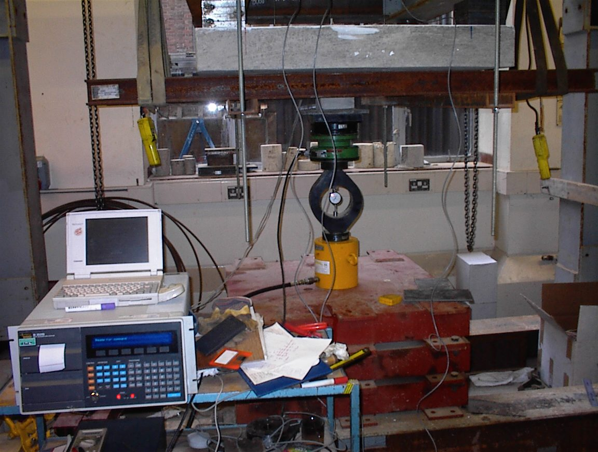
Fig. 1–An overview of a specimen in position ready for testing.

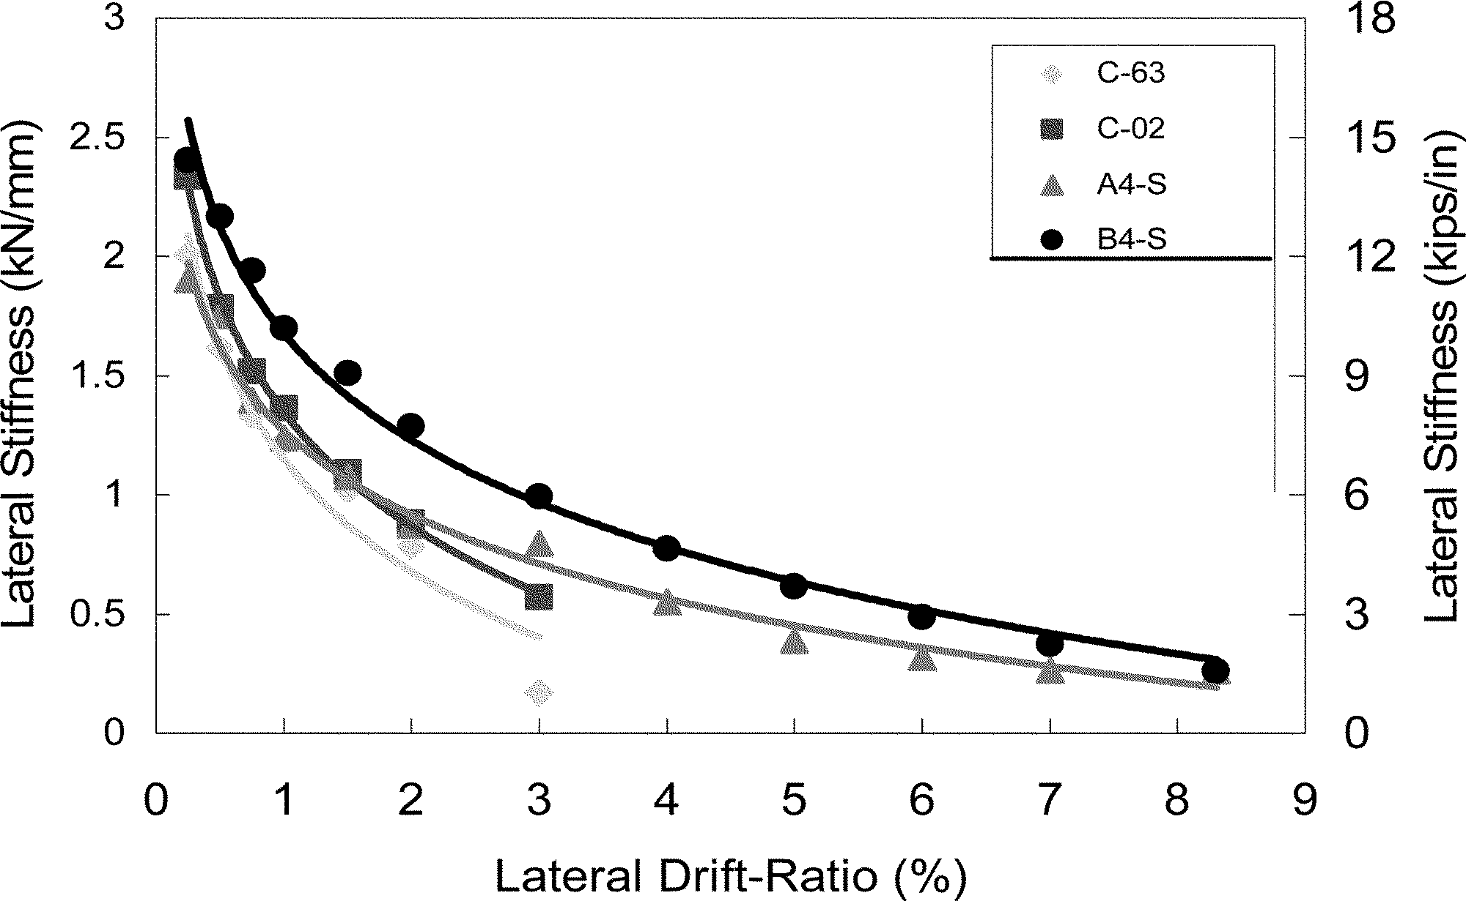
Fig. 6–Peak lateral stiffness versus applied drift ratio.
(Add dual units opposite to main units only if units are in US [in.-lb])
(In the case of very complex and large tables and figures, two options are acceptable:
(a) Provide a duplicate table or figure with the secondary units.
(b) Provide the conversion factors for the units used in the table or figure under the table or figure (only possible if space prevents item (a)).

